NSBM Green University
SE102.3 Web Based Application Development
Web Design - Repeat Coursework
PROJECT REPORT
Daily Pulse News
Online News Website with Admin Features
Detail | Value
Student Name | Kariyawasam K P P S
Index Number | 26778
Module Leader | S. Naji
GitHub Repository | https://github.com/kariyawasamp679-create/news-portal-web-app
GitHub: https://github.com/kariyawasamp679-create/news-portal-web-app

Table of Contents
1. Introduction 3
2. Proposal 3
2.1 Problem statement 3
2.2 Objectives 3
2.3 Scope 3
2.4 Technologies 3
2.5 User roles 3
3. UI Plan (Web Design) 4
3.1 Layout and style 4
3.2 Wireframes 4
3.3 Site map 5
4. Website GUI 6
4.1 Public website 6
4.2 Admin panel 11
5. Database Design 17
5.1 Tables 17
5.2 Relationships (ER diagram) 18
5.3 DML operations 18
5.4 Database in phpMyAdmin 19
6. Security 20
7. GitHub and Contributions 20
8. Testing 21
9. How to Run the Project 21
10. Conclusion 21

1. Introduction
Daily Pulse News is a dynamic online news portal. Readers can browse the latest stories, filter them by category, search for topics and leave comments. Editors and administrators use a protected admin panel to publish and manage the content. The website is backed by a MySQL database and supports all DML operations (INSERT, SELECT, UPDATE and DELETE).
The project satisfies the coursework requirements: a planned UI, a website with more than four main pages, a database with all DML operations, an admin section, and GitHub for version control and contribution tracking.

2. Proposal

2.1 Problem statement
Small news organisations need a simple and affordable way to publish stories online and manage them without editing code.

2.2 Objectives
- Provide a clean, responsive public news website.
- Provide an admin panel for managing articles, categories, comments, messages and users.
- Store all data in a relational database.
- Use GitHub for version control and to show contributions.

2.3 Scope
Public pages: Home, Category, Article, Search, About Us and Contact Us.
Admin pages: Login, Dashboard, Articles, Categories, Comments, Messages and Users.

2.4 Technologies
Area | Technology
Back end | PHP 8 with PDO
Database | MySQL / MariaDB
Front end | HTML5, CSS3
Server | XAMPP (Apache)
Version control | Git and GitHub
Editor | Visual Studio Code

2.5 User roles
- Visitor - reads, searches, comments and sends messages.
- Editor - logs in and manages articles, categories, comments and messages.
- Admin - everything an editor can do, plus user management.

3. UI Plan (Web Design)

3.1 Layout and style
Every page shares a consistent header (logo and search box), a dark navigation bar with category links, a main content area and a footer.
Element | Choice
Accent colour | Red #C8102E
Navigation / footer | Charcoal #1B1F27
Panels | Light grey #F3F4F6
Typography | Segoe UI / Arial; section titles have a red left border
Responsive | Three-column grids collapse to one column below 800px

3.2 Wireframes
The wireframes below were drawn before development to plan the page structure. Coloured blocks mark the main regions of each page.
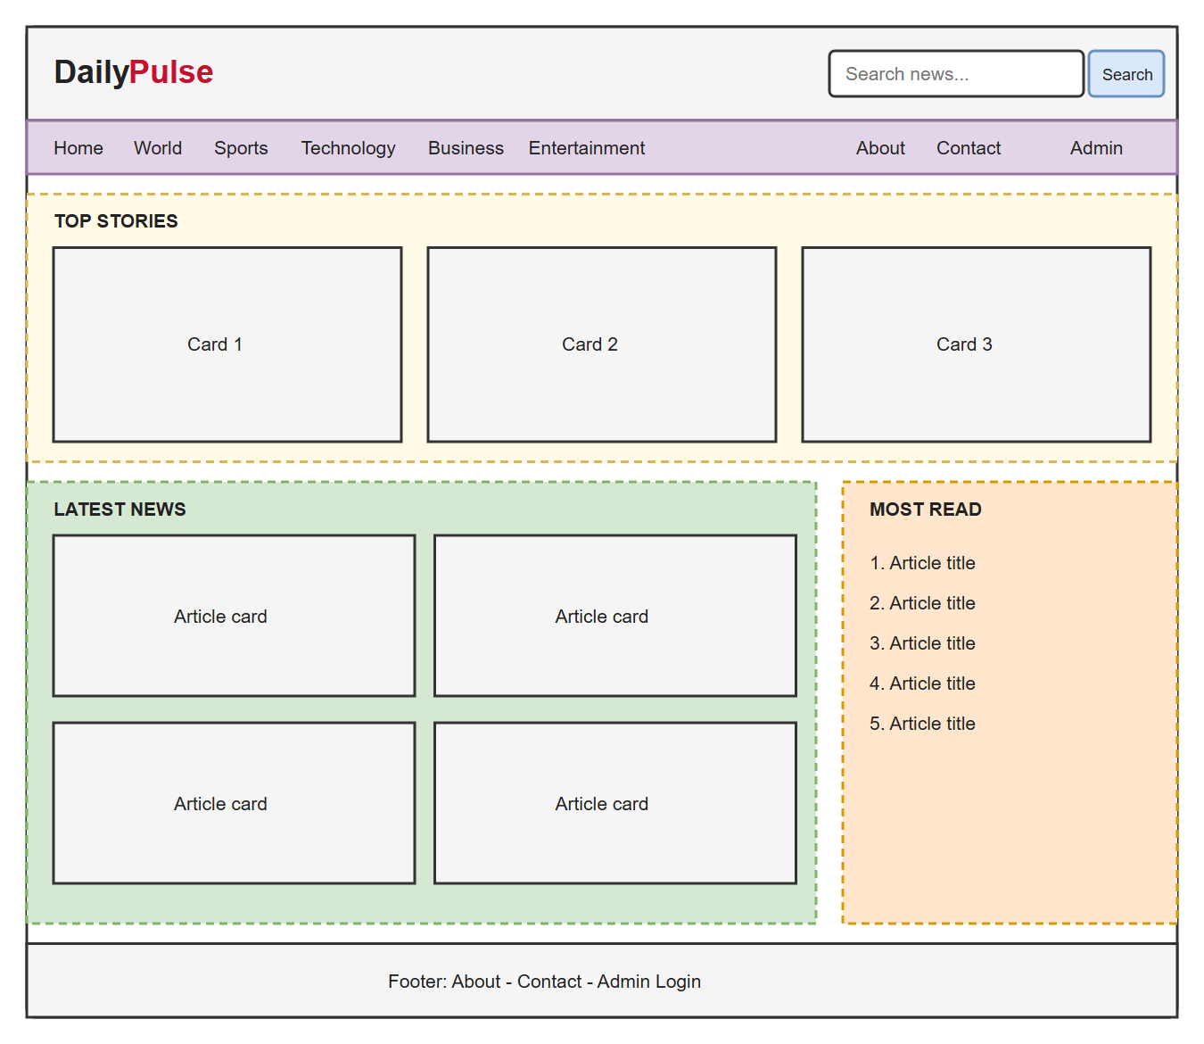
Figure 1: Wireframe - Home page
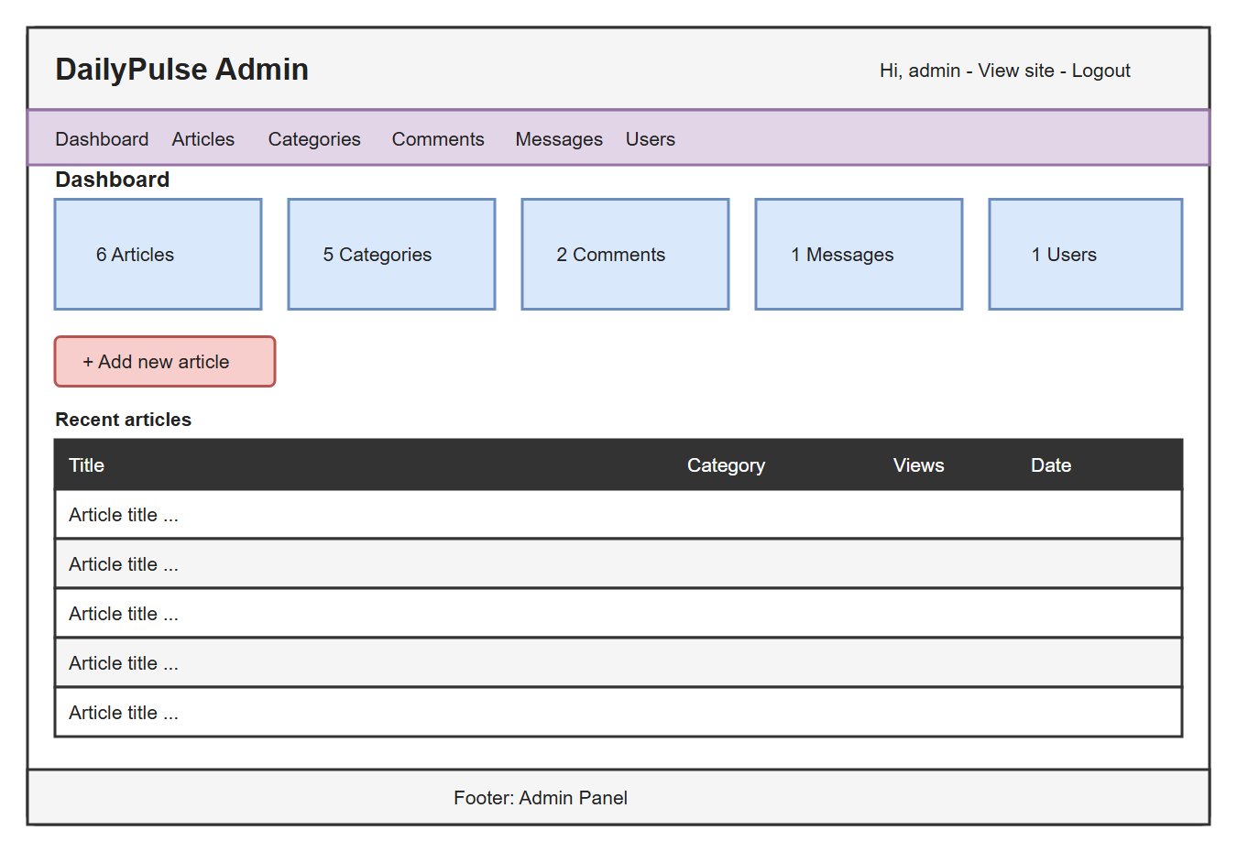
Figure 2: Wireframe - Admin dashboard

3.3 Site map
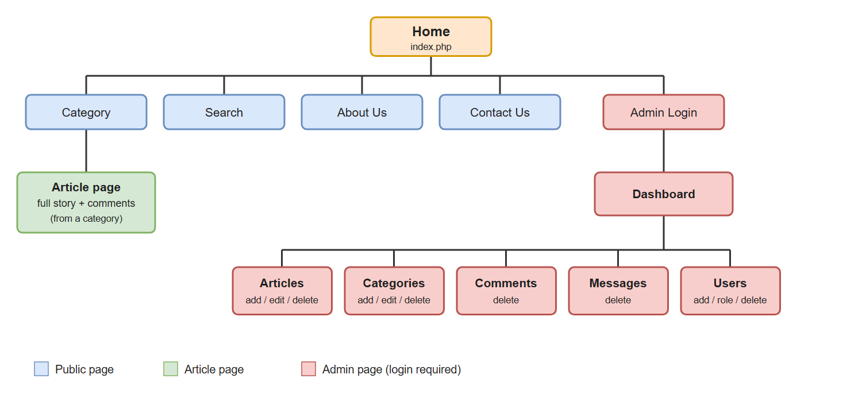
Figure 3: Site map of the website

4. Website GUI
This section shows the implemented pages. The public site has six pages and the admin panel has seven.

4.1 Public website

Home page
Shows Top Stories (featured articles), the Latest News grid and a Most Read sidebar ordered by view count.
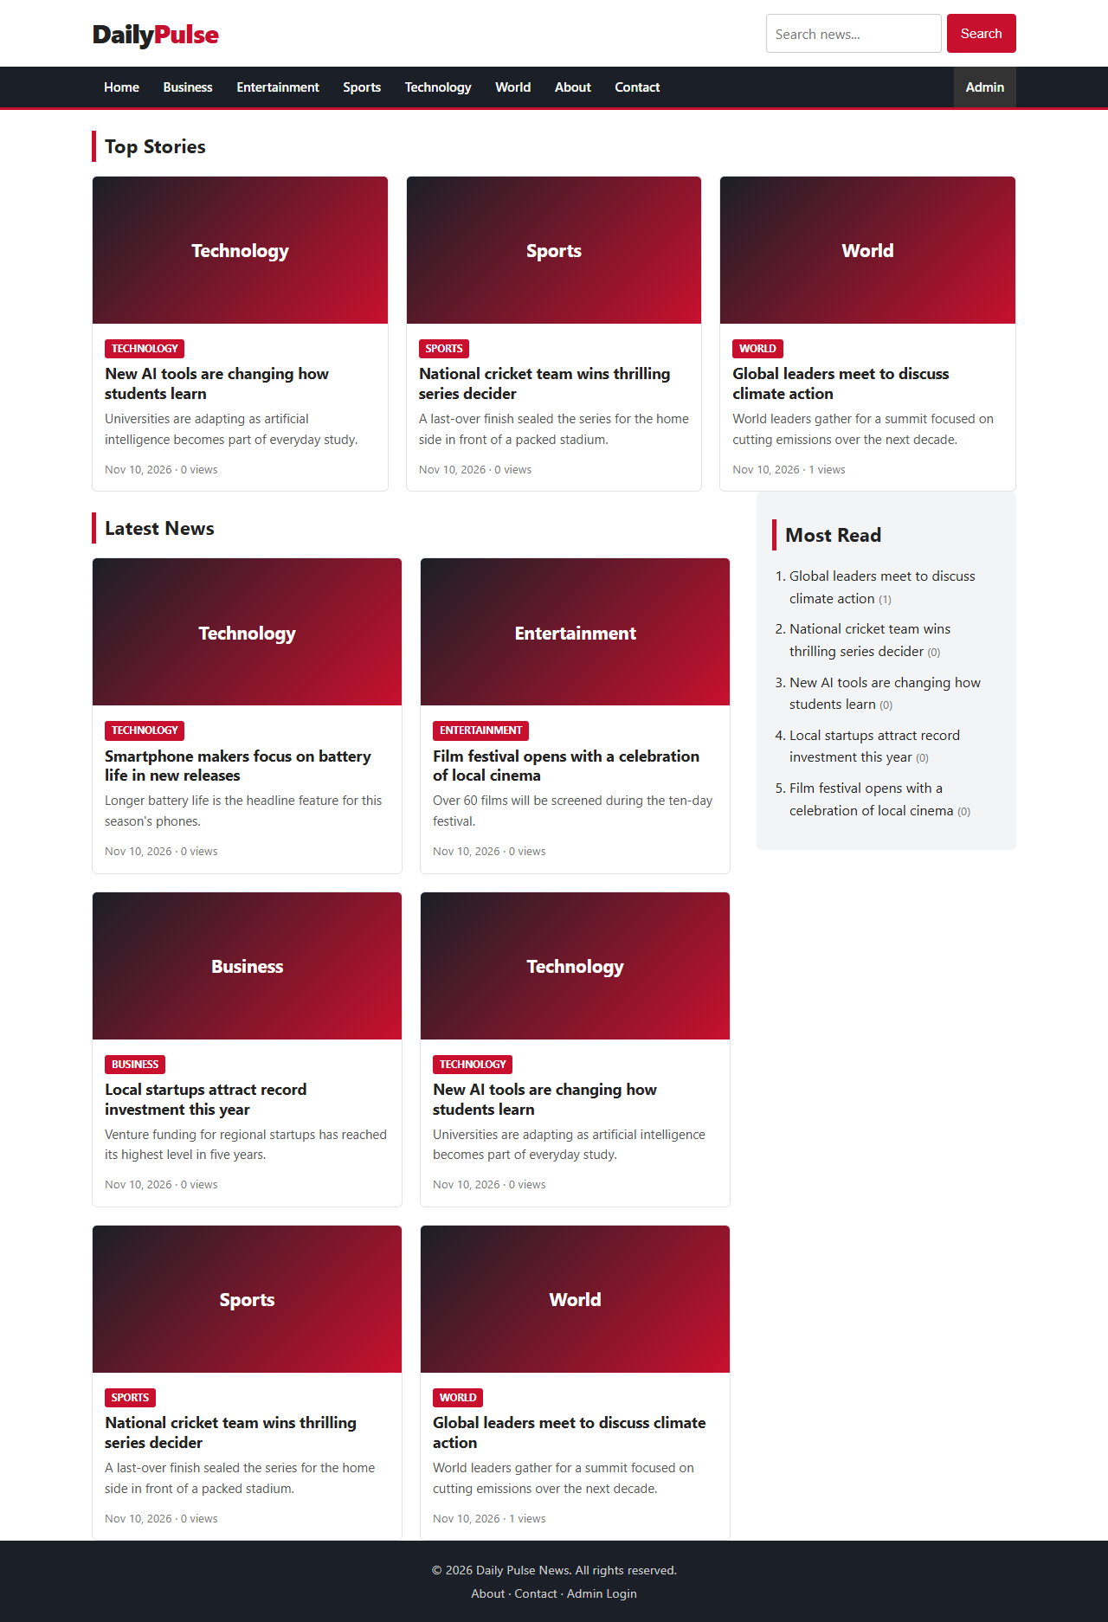
Figure 4: Home page

Category page
Lists every article that belongs to the selected category.
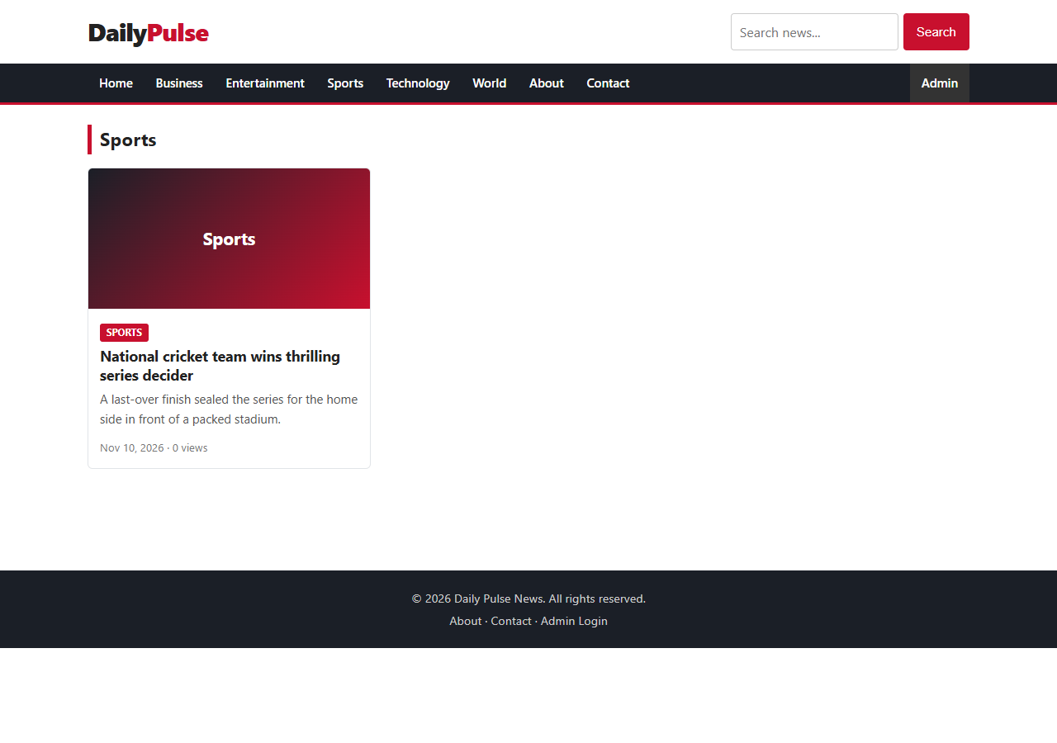
Figure 5: Category page (Sports)

Article page
Shows the full story, author, date and view count. Visitors can post comments.
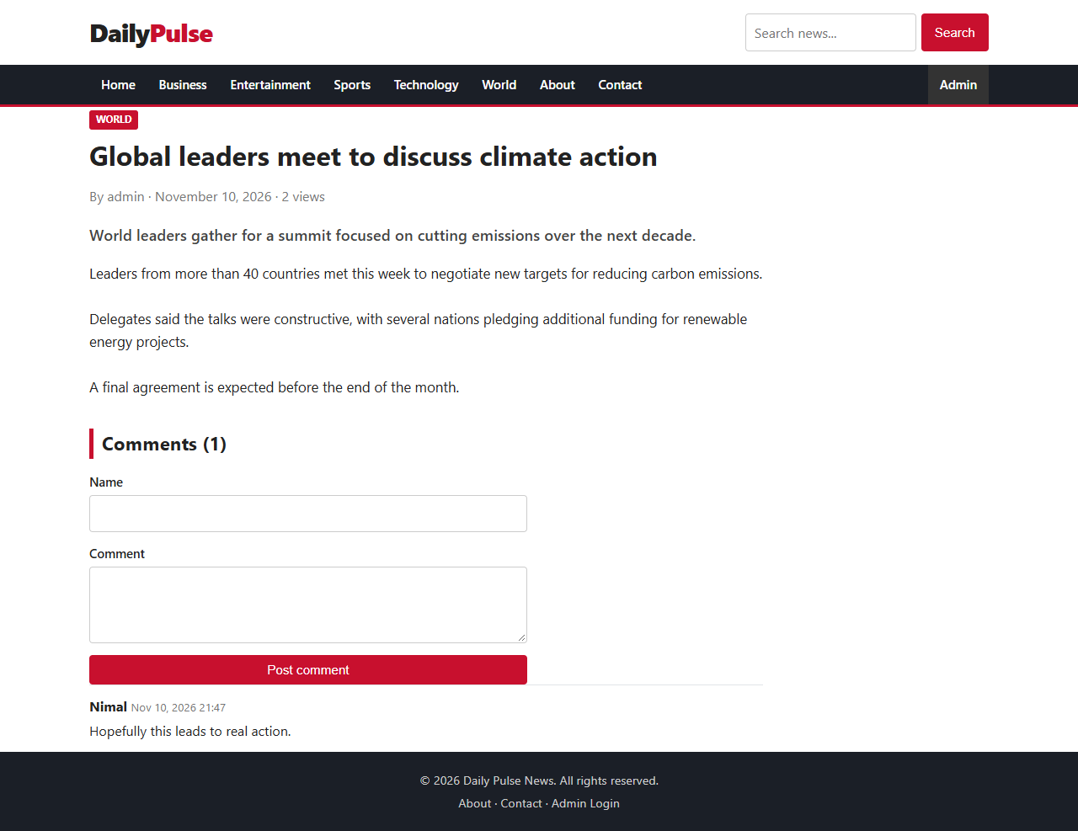
Figure 6: Article page with comments

Search page
Searches the title, summary and content of all articles.
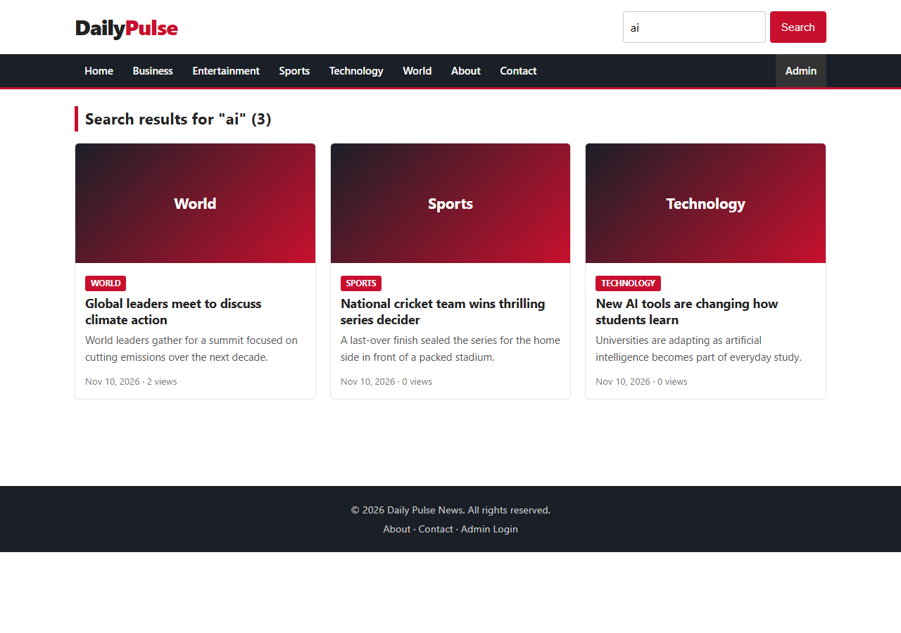
Figure 7: Search results

About Us page
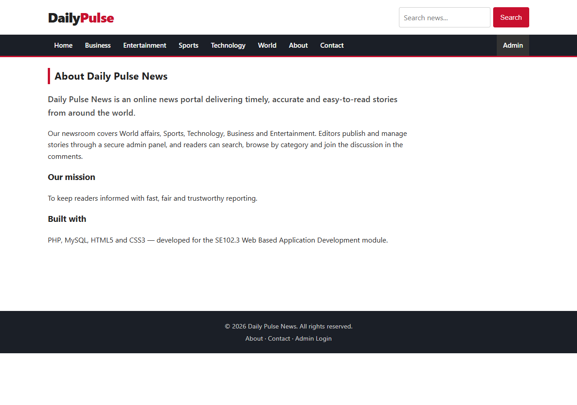
Figure 8: About Us page

Contact Us page
Validated form. Submitted messages are stored in the messages table.
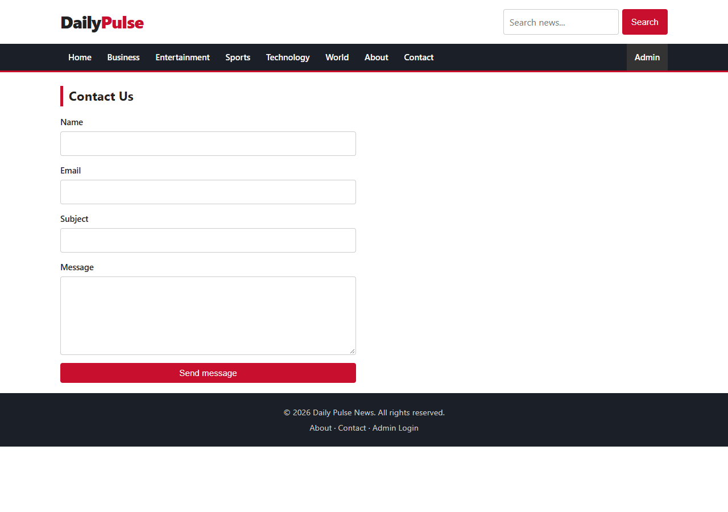
Figure 9: Contact Us page

4.2 Admin panel

Admin login
Staff sign in with a username and password. Passwords are stored as bcrypt hashes.
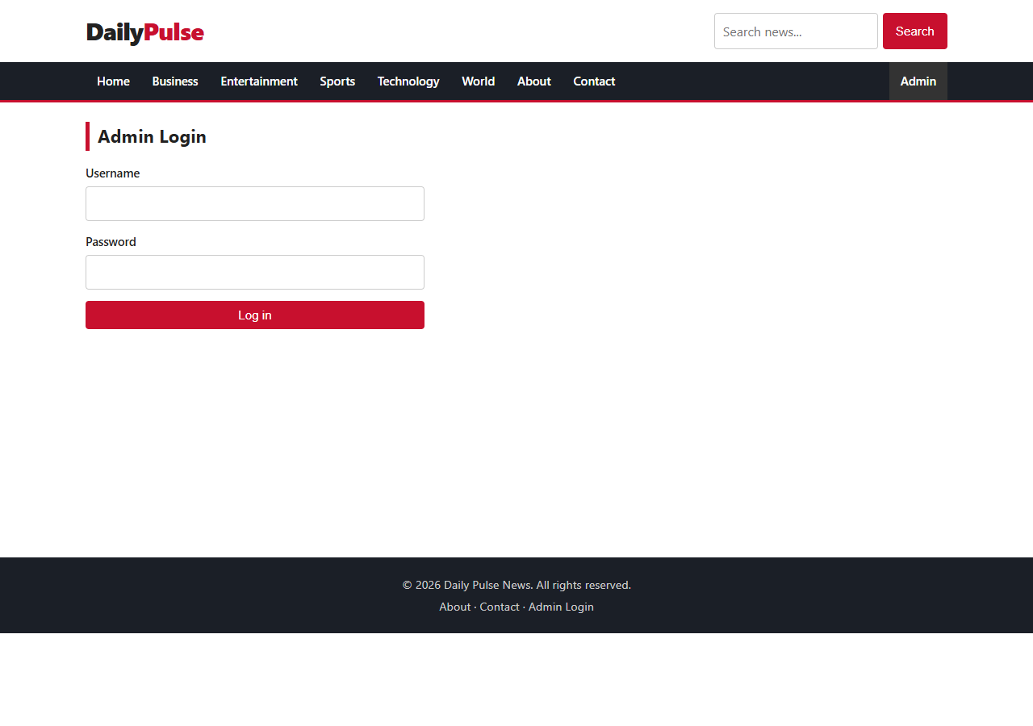
Figure 10: Admin login

Dashboard
Displays totals for articles, categories, comments, messages and users, and the five most recent articles.
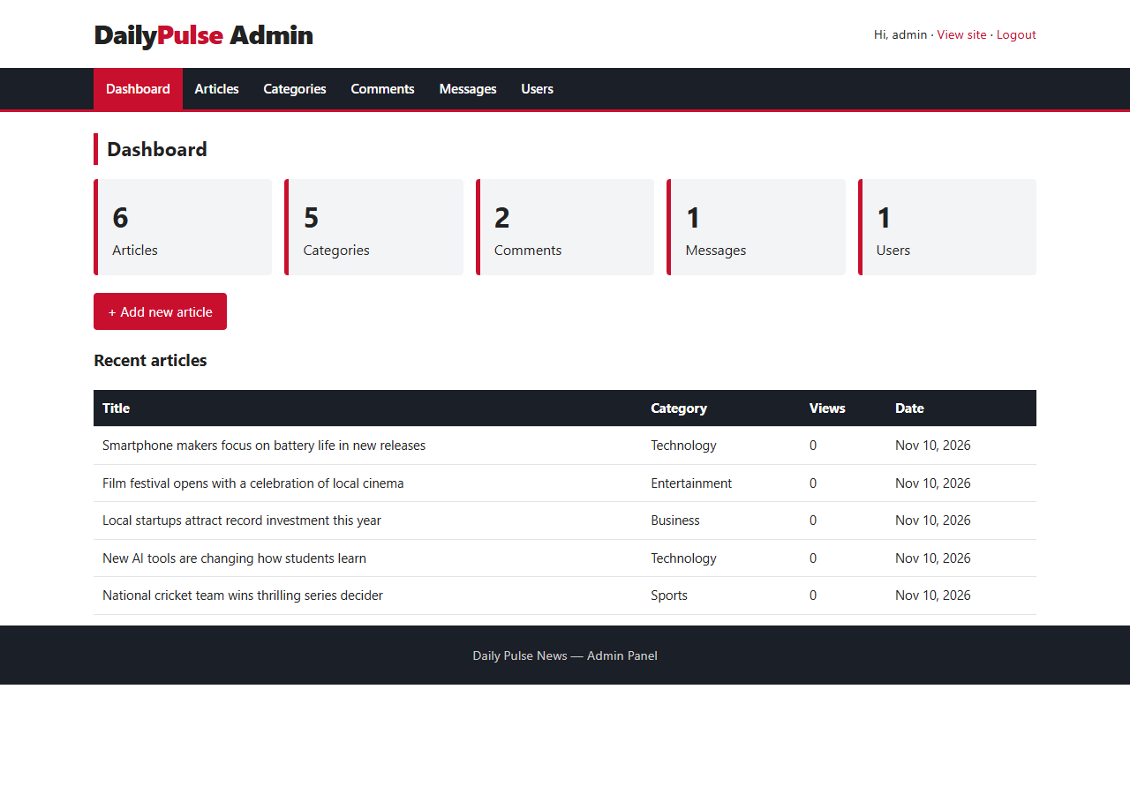
Figure 11: Admin dashboard

Manage articles
Table of all articles with View, Edit and Delete actions.
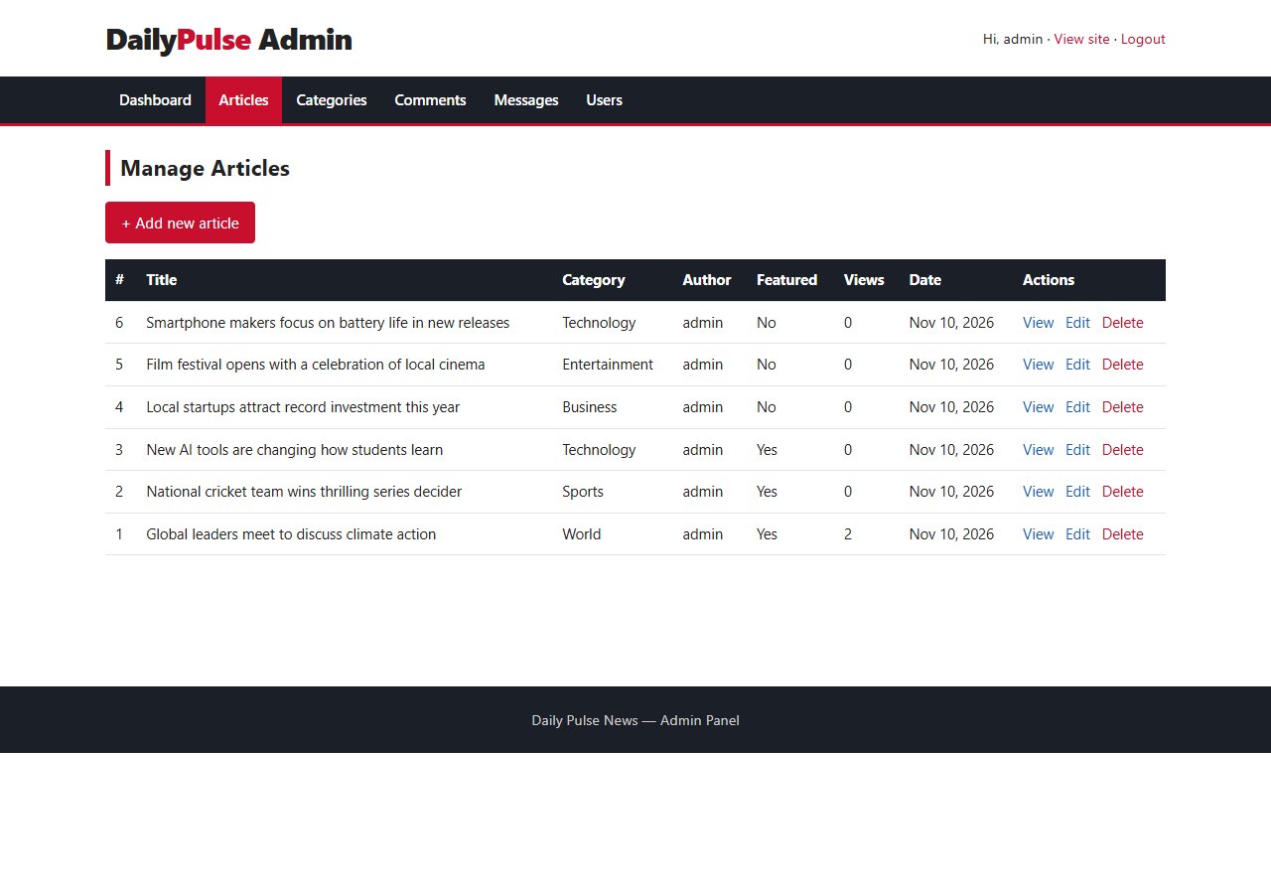
Figure 12: Manage articles

Add / edit article
Form with title, category, summary, content, optional image upload and a Top Stories option.
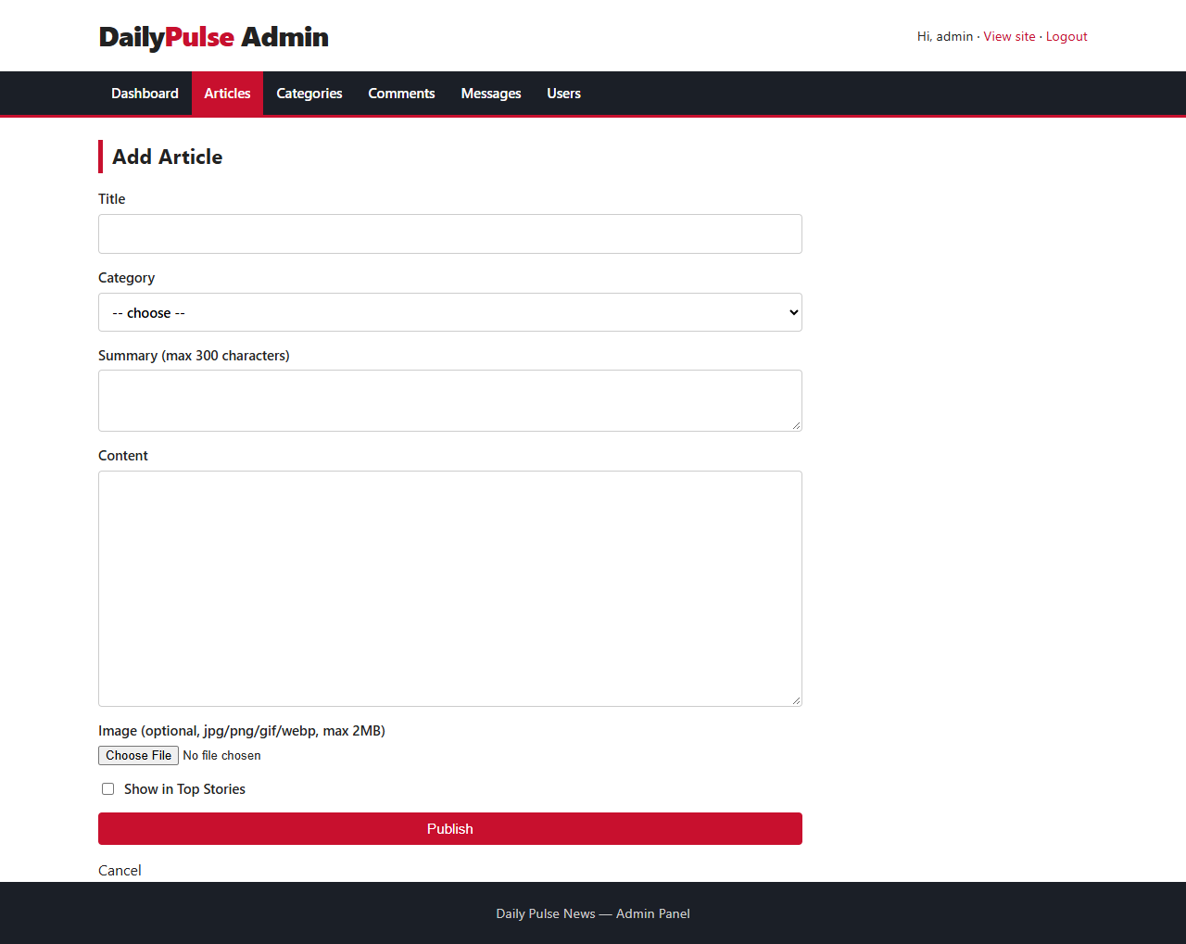
Figure 13: Add article form

Manage categories
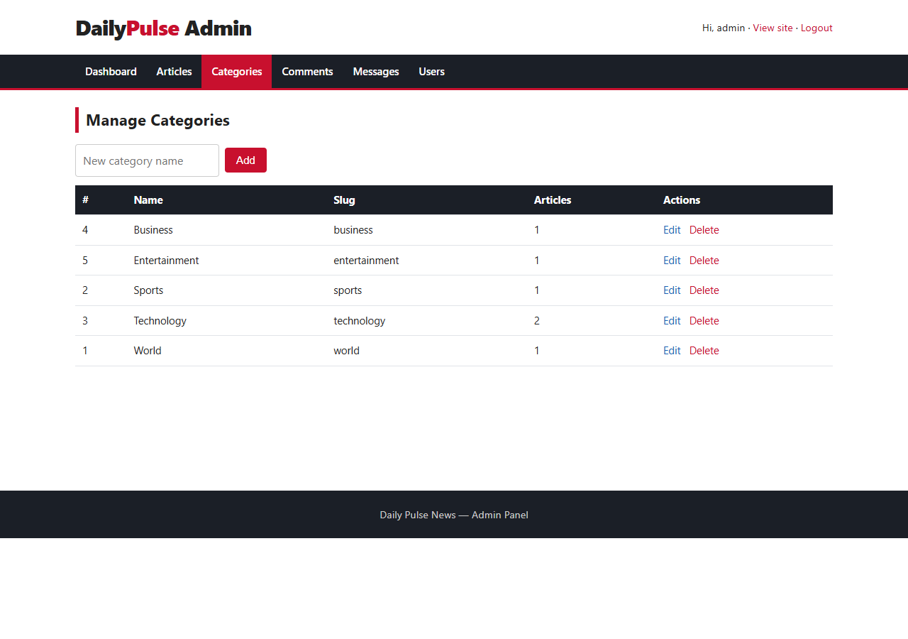
Figure 14: Manage categories

Moderate comments
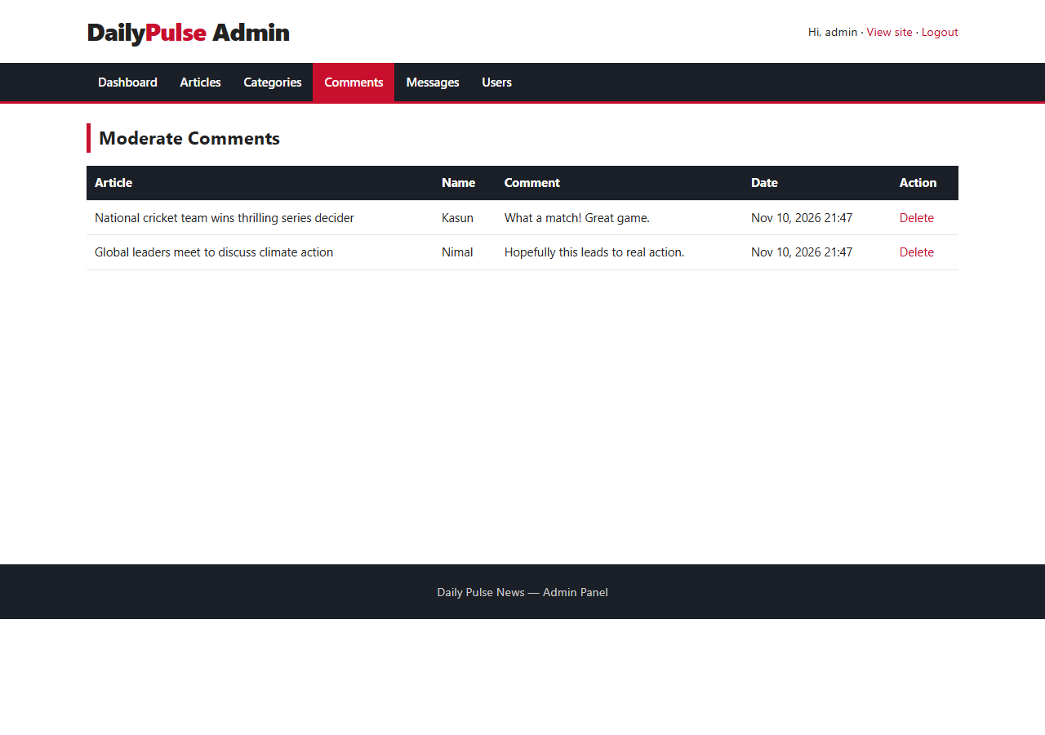
Figure 15: Moderate comments

Contact messages
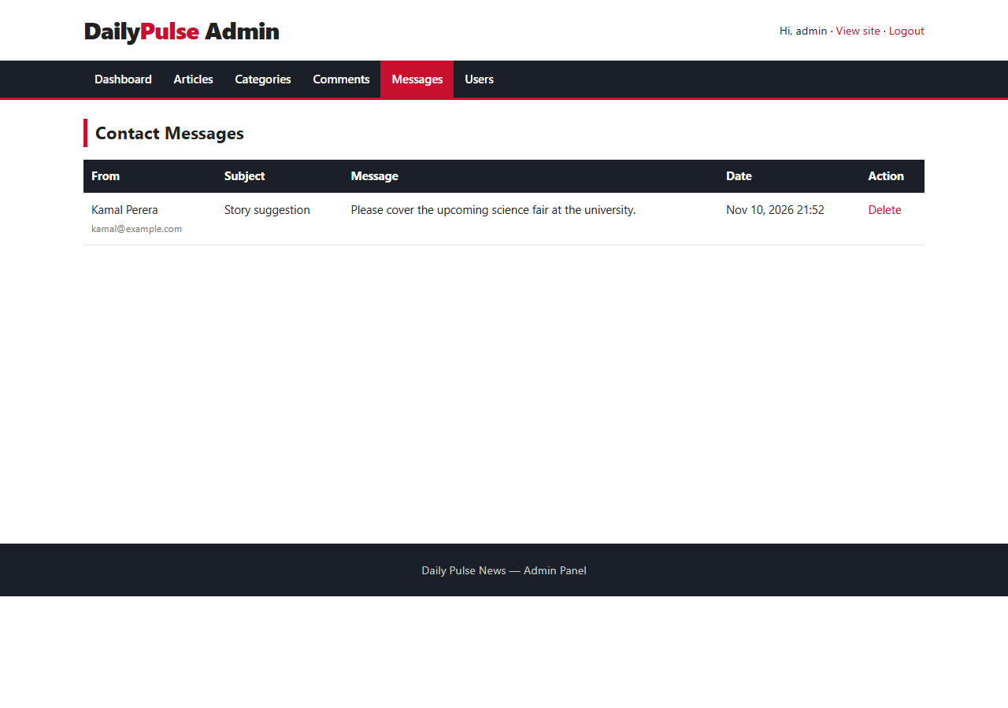
Figure 16: Contact messages

Manage users
Available to administrators only. Roles can be changed and users removed (the signed-in user cannot delete or demote themselves).
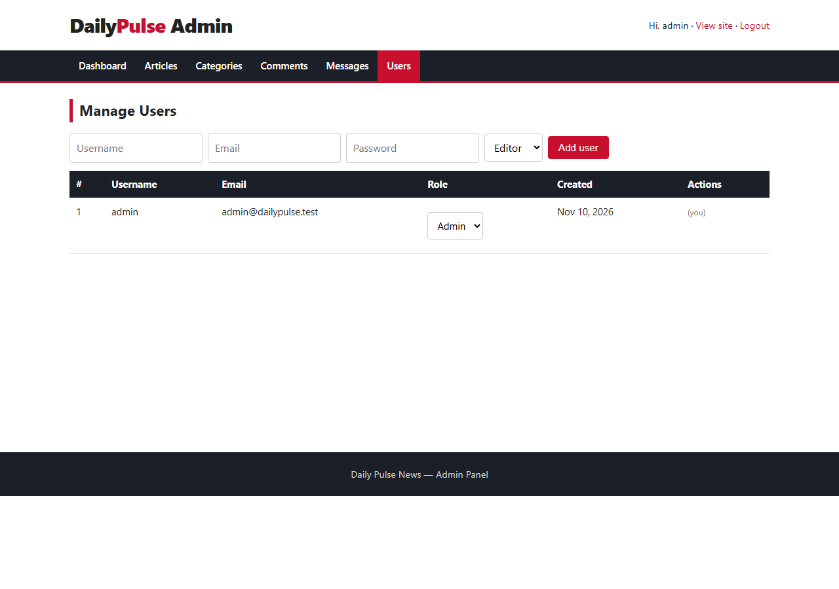
Figure 17: Manage users

5. Database Design
Database name: news_portal (engine InnoDB, character set utf8mb4). The full script is in database/schema.sql.

5.1 Tables

users
Column | Type | Notes
id | INT, PK, AUTO_INCREMENT
username | VARCHAR(50) | UNIQUE
email | VARCHAR(100) | UNIQUE
password | VARCHAR(255) | bcrypt hash
role | ENUM('admin','editor') | default editor
created_at | TIMESTAMP

categories
Column | Type | Notes
id | INT, PK, AUTO_INCREMENT
name | VARCHAR(60) | UNIQUE
slug | VARCHAR(80) | UNIQUE, used in URLs

articles
Column | Type | Notes
id | INT, PK, AUTO_INCREMENT
title | VARCHAR(200)
summary | VARCHAR(300)
content | TEXT
image | VARCHAR(255), NULL | file name in /uploads
category_id | INT, FK | categories(id), ON DELETE CASCADE
author_id | INT, FK | users(id), ON DELETE CASCADE
is_featured | TINYINT(1) | shown in Top Stories
views | INT | incremented on each view
created_at | TIMESTAMP

comments
Column | Type | Notes
id | INT, PK, AUTO_INCREMENT
article_id | INT, FK | articles(id), ON DELETE CASCADE
name | VARCHAR(80)
body | TEXT
created_at | TIMESTAMP

messages
Column | Type | Notes
id | INT, PK, AUTO_INCREMENT
name | VARCHAR(80)
email | VARCHAR(100)
subject | VARCHAR(150)
message | TEXT
created_at | TIMESTAMP

5.2 Relationships (ER diagram)
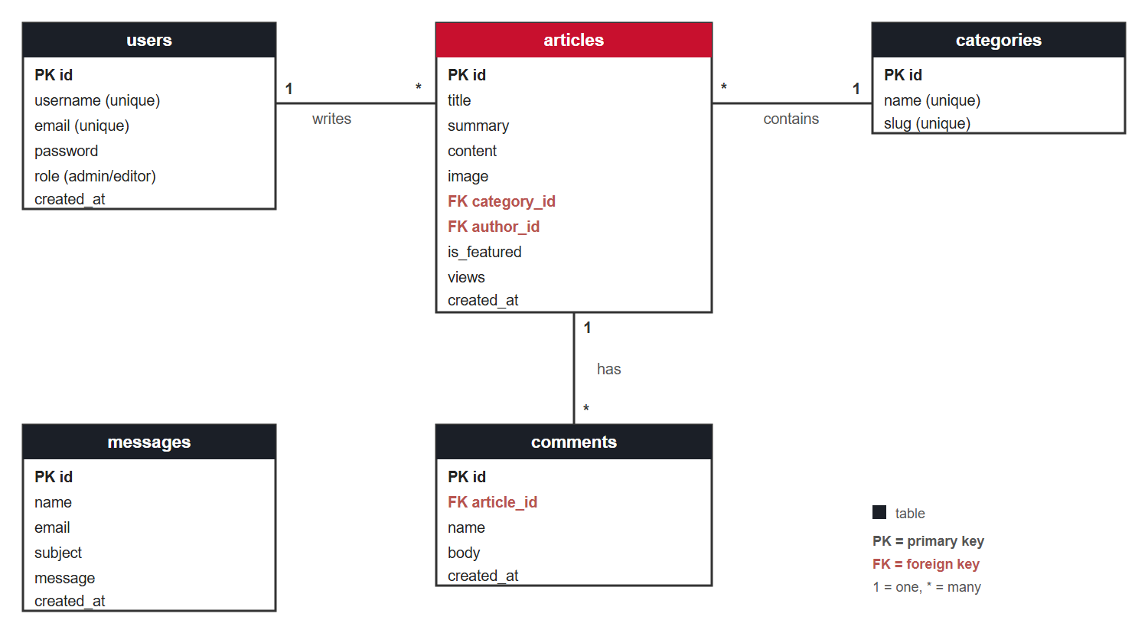
Figure 18: Entity relationship diagram
- One user writes many articles.
- One category contains many articles.
- One article has many comments.

5.3 DML operations
Operation | Example | File
INSERT | INSERT INTO articles (...) VALUES (?,...) | admin/article_form.php
INSERT | INSERT INTO comments ... | article.php
INSERT | INSERT INTO messages ... | contact.php
SELECT | SELECT a.*, c.name FROM articles a JOIN categories c ... | index.php, category.php
SELECT | ... WHERE title LIKE ? OR summary LIKE ? OR content LIKE ? | search.php
UPDATE | UPDATE articles SET title=?, ... WHERE id=? | admin/article_form.php
UPDATE | UPDATE articles SET views = views + 1 | article.php
DELETE | DELETE FROM articles WHERE id = ? | admin/articles.php
DELETE | categories, users, comments, messages | admin/*.php

5.4 Database in phpMyAdmin
The news_portal database contains five InnoDB tables with sample data, as shown below.
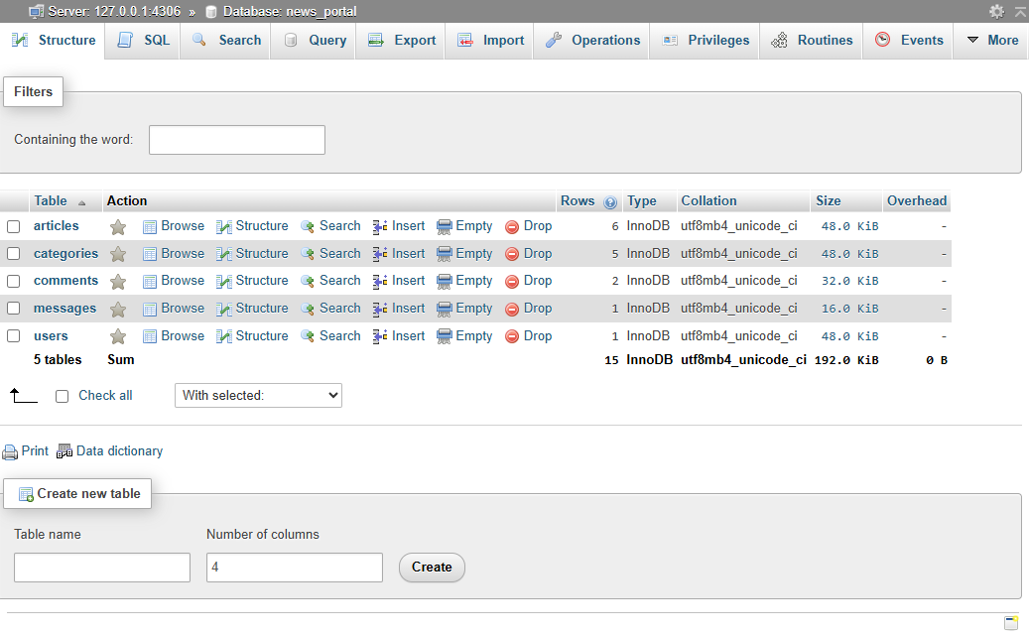
Figure 19: Tables of the news_portal database in phpMyAdmin
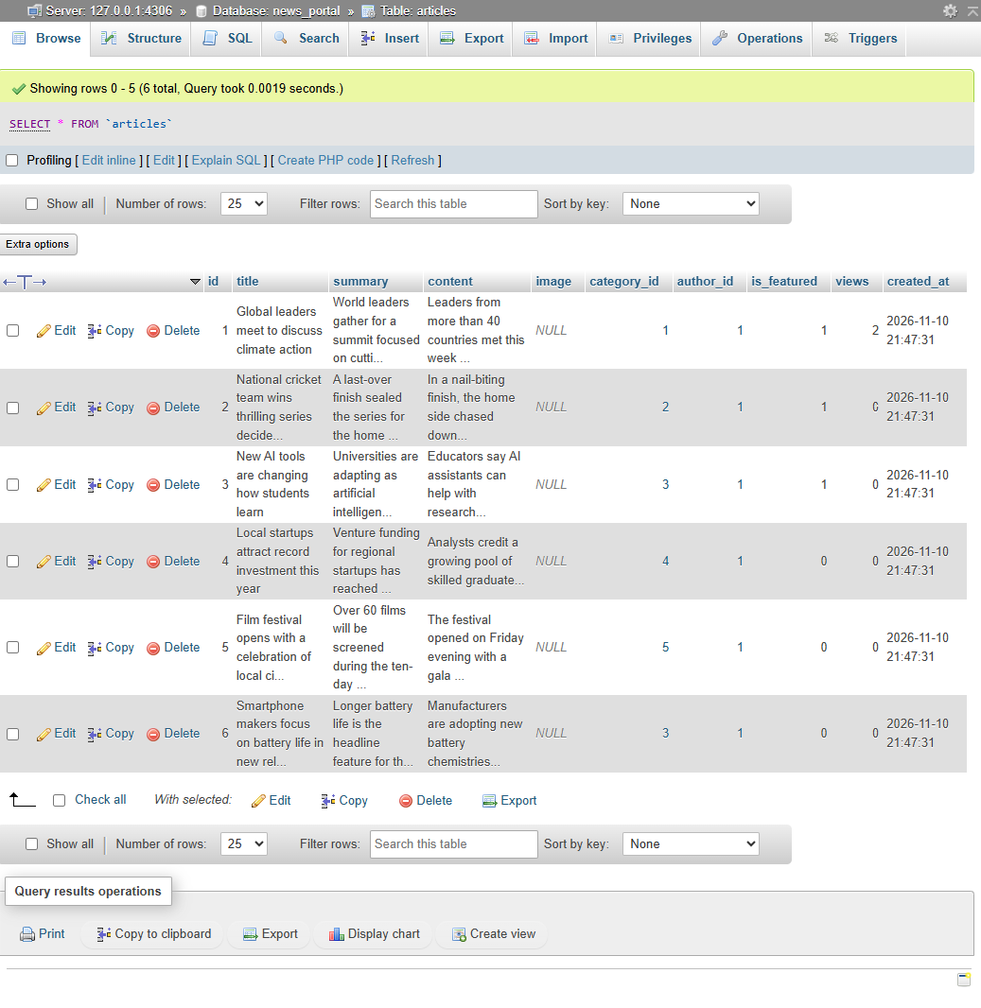
Figure 20: Contents of the articles table

6. Security
- Passwords are stored with password_hash() and verified with password_verify().
- All SQL uses PDO prepared statements, which prevents SQL injection.
- All output is escaped with htmlspecialchars(), which prevents XSS.
- A CSRF token protects every form that changes data.
- Admin pages require a login session; user management is limited to the admin role.
- Image uploads are restricted by file type and size and saved with random file names.

7. GitHub and Contributions
Repository: https://github.com/kariyawasamp679-create/news-portal-web-app
The work was committed in stages so that the history shows how the project was developed:
No. | Commit message
1 | Add database schema, sample data and configuration
2 | Add public pages: home, category, article, search, about, contact and login
3 | Add admin panel with article, category, comment, message and user management
4 | Add responsive stylesheet
5 | Add README and project report

The Insights > Contributors page and the commit history of the repository show the contribution timeline.

8. Testing
Test | Result
All public pages load without errors | Pass
Admin login with correct password | Pass
Admin login with wrong password is rejected | Pass
Admin pages redirect to login when not signed in | Pass
Create, edit and delete an article | Pass
Add a category | Pass
Post a comment | Pass
Send a contact message | Pass
Search returns matching articles | Pass

9. How to Run the Project
- Copy the project folder to C:\xampp\htdocs\news-portal.
- Start Apache and MySQL in the XAMPP Control Panel.
- Open phpMyAdmin, choose Import, select database/schema.sql and click Go.
- Open http://localhost/news-portal/ in a browser.
- Admin login: http://localhost/news-portal/login.php (username: admin, password: Admin@123).

10. Conclusion
The project delivers a complete, database-driven news website with a secure admin panel and full DML support, built and tracked on GitHub. Possible future improvements include a rich-text editor, article scheduling, pagination, and reader registration.

